**GENERAL HUMAN BIOLOGY UNIT 4**

**TASK 11 – Hygiene Practises Extended Response**

**NAME:_______________________________________ WEIGHTING: 10% MARK:**

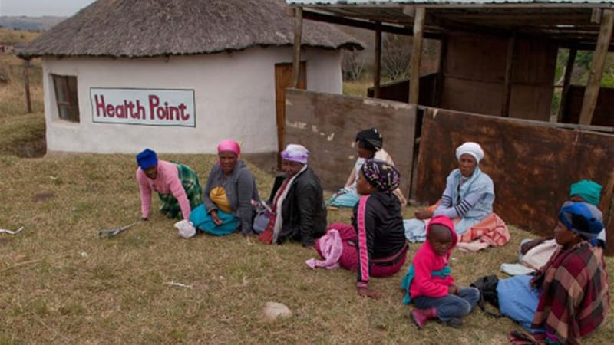

**Curriculum Points:**

* population density and movement patterns influence the transmission of disease
* international collaboration is often required when responding to global issues of disease transmission, such as severe acute respiratory syndrome (SARS) and bird flu, and reducing the impact of foreign disease on isolated populations
* the introduction of foreign bacteria and viruses to isolated communities may have a more severe affect than in the outside world

**Assessment Policy:**

* All work in each individual assessment task must be the work of the student
* For any late out-of-class assessment task, where the student **does not** provide a reason which is acceptable to the college, the following penalties apply:
  + - *10% reduction in the mark (if submitted one day late)* ***or***
    - *20% reduction in the mark (if submitted two days late)* ***or***
    - *30% reduction in the mark (if submitted three days late)* ***or***
    - *50% reduction in the mark (if submitted more than three days late)*

Due Date: ____________________________________

**PRIVATE AND CONFIDENTIAL**

**The following pages are classified and confidential. The sharing of any of this information with others, intentionally or otherwise, directly contravenes international law.**

|  |  |  |  |  |
| --- | --- | --- | --- | --- |
| **CONTRACTORS NAME** | |  | **DATE FOR RETURN** |  |
| **Case Summary** | | | | |
| A highly virulent strain of Influenza A has been reported in the isolated mountain community of La Rinconada, Peru (map attached). It is believed that the strain was introduced to La Rinconada by a Californian tourist wanting to explore the prospecting town. Blood analysis in 53 citizens has so far revealed a total absence of antibodies for any influenza strain, leading to the belief that the community has never been exposed to influenza. Further blood analysis is currently being conducted.  La Rinconada has limited interaction with the outside world, aside from the trading of gold with the nearby towns of Cuyocuyo and Ananea. So far as testing has revealed, the virus has yet to reach either community. The virus has already claimed the lives of twelve La Rinconada citizens, though as many as 153 others are infected. | | | | |
| **Contractor requirements** | | | | |
| The United Nations need a solution to prevent the spread of a virulent strain of influenza that has struck a Peruvian community. You have been contracted to find useful precedent to support the UN in this endeavour, and to propose a solution to prevent the spread of this influenza virus beyond La Rinconada, and minimise the effect the virus has on this community, without compromising the cultural values or economic needs of the communities. | | | | |
| **TASK ONE SUMMARY**  **(20%)** | This is not the first time that a foreign disease has struck an isolated community, nor the first time that international collaboration has been necessary to minimise the damage inflicted by a disease. Historical incidences include:   * The Spanish introducing influenza to the Aztecs * The British introducing chlamydia to the Indigenous Americans * Whooping Cough being introduced to Papua New Guinea * Spanish Flu being introduced to the Inuit Okak community * A carpenter from Denmark introducing measles to the Faroe Islands in 1846 * Smallpox being introduced to Rio Bio Bio in 1791   You need to:   * Choose two of the above historical epidemics. Create research notes about how the community was affected by the disease. Use both primary and secondary sources of data to validate your research. * Explain why the two communities were so dramatically affected by the diseases. Consider physical, social, cultural and economic factors. | | | |
| **TASK TWO**  **SUMMARY**  **(20%)** | Research the modern disease epidemics of Ebola, Bird Flu and SARS, and look at what was done by local, regional and international organisations to minimise the spread of the disease and support the communities while a vaccine was being developed.  You’ll need to:   * Identify what each disease is and its main symptoms * Describe what happened with the disease outbreak (who, what, when, where) * Explain how the local communities responded to the outbreaks * Explain how International communities responded to the outbreaks (United Nations, World Health Organisation, Red Cross, etc). | | | |
| **TASK THREE**  **(60%)** | Design a solution to prevent the spread of this influenza virus to Cuyocuyo and Ananea and minimise the effect the virus has on La Rinconada, without compromising the cultural values or economic needs of the communities.  In your proposal, you’ll need to consider how to reduce hysteria, on-the-ground medical procedures, quarantine and isolation, financial factors, cultural and religious considerations and how to maintain the towns economic security. | | | |

|  |
| --- |
| **TASK ONE RESEARCH NOTES** |
| **HISTORICAL PRECEDENT 1** |
|  |
| **HISTORICAL PRECEDENT 2** |
|  |
| REFERENCES |
|  |
| **TASK TWO RESEARCH NOTES** |
| **Bird Flu** |
| **Identify what each disease is and its main symptoms**    **Describe what happened with the disease outbreak (who, what, when, where)**  **Explain how the local communities responded to the outbreaks**  **Explain how International communities responded to the outbreaks (United Nations, World Health Organisation, Red Cross, etc).** |
| REFERENCES |
|  |
| **TASK TWO RESEARCH NOTES** |
| **SARS** |
| **Identify what each disease is and its main symptoms**    **Describe what happened with the disease outbreak (who, what, when, where)**  **Explain how the local communities responded to the outbreaks**  **Explain how International communities responded to the outbreaks (United Nations, World Health Organisation, Red Cross, etc).** |
| REFERENCES |
|  |
| **TASK TWO RESEARCH NOTES** |
| **Ebola** |
| **Identify what each disease is and its main symptoms**    **Describe what happened with the disease outbreak (who, what, when, where)**  **Explain how the local communities responded to the outbreaks**  **Explain how International communities responded to the outbreaks (United Nations, World Health Organisation, Red Cross, etc).** |
| REFERENCES |
|  |
| **Proposal to the United Nations** |
| **On-the-ground medical procedures** |
|  |
| **Quarantine and isolation** |
|  |
| **Financial factors** |
|  |
| **Cultural and religious considerations** |
|  |
| **How to maintain the towns economic security** |
|  |
| **How to reduce hysteria** |
|  |
| This proposal was devised by _________________________ to support the community of La Rinconada in their battle with Influenza.  Signed: ___________________________ Date: __________________ |

